Experiment No. 3

**Aim:** You are given three tables: Students, Friends and Packages. Students contains two columns: ID and Name. Friends contains two columns: ID and Friend_ID (ID of the ONLY best friend). Packages contains two columns: ID and Salary (offered salary in $ thousands per month).

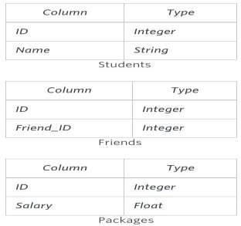

Write a query to output the names of those students whose best friends got offered a higher salary than them. Names must be ordered by the salary amount offered to the best friends. It is guaranteed that no two students got same salary offer.

**Objective:** To extract the data from relations and analyze the results using sql concepts

Solution:

CREATE TABLE students (id int, NAME VARCHAR(30));

CREATE TABLE packages (id int, salary INT);

CREATE TABLE friends (id int, friend_id INT);

INSERT INTO students values (1,'John');

INSERT INTO students values (2,'Arthur');

INSERT INTO students values (3,'Pete');

INSERT INTO packages values (1,1000);

INSERT INTO packages values (2,1200);

INSERT INTO packages values (3,800);

INSERT INTO friends values (1,2);

INSERT INTO friends values (2,3);

INSERT INTO friends values (3,1);

select * from students;

select*from packages;

select * from friends;

SELECT name from students s, friends f, packages p, packages p1 where s.id=f.id and s.id=p.id and f.friend_id=p1.id and p.salary<p1.salary order by p1.salary;

